Zion’s Camp
Disciple’s Guide



This guide belongs to __________________________

Contents

 Read This First 3
Introduction 4
Schedule 5
Your Backstory 8
Zion’s Camp Experience 9
Daily Devotions 10
Daily Diligences 11
Historical Figures 12
Artifacts 13
Challenges 15
Mysteries 17
Card Canvas 18
Company Captains 21
Messenger Bag 22
Adult Leaders 23
Newel K. Whitney’s Store 24
Sustenance (that means food!) 25
Reward Table Summary 26
Personal Study 27
Kirtland (Ayatma) Map 30

Read This First

This is 100% your adventure.

Adults will make sure you’re safe.

But they won’t tell you to get up on time or go to bed or clean your camp or follow the schedule.

You’re responsible for that. All that.

Yup, you.

You’re in charge of reading this guide and charting your course at camp.

And you can do it. There is greatness in you!

Read on...

Introduction
Welcome young disciples!
Welcome to Zion’s Camp, a multi-day journey based on the experiences of early Latter-day Saints during the Kirtland era of the church.
You form one of eight “companies” based on actual historical figures who took part in Zion’s Camp. With your brothers-at-arms, you will complete physical, mental, and spiritual challenges in your quest to redeem Zion and more.
This book is your guide. Read every word and guard it with your life. It will lead you in the way of excellence and awesomeness.
Onward!

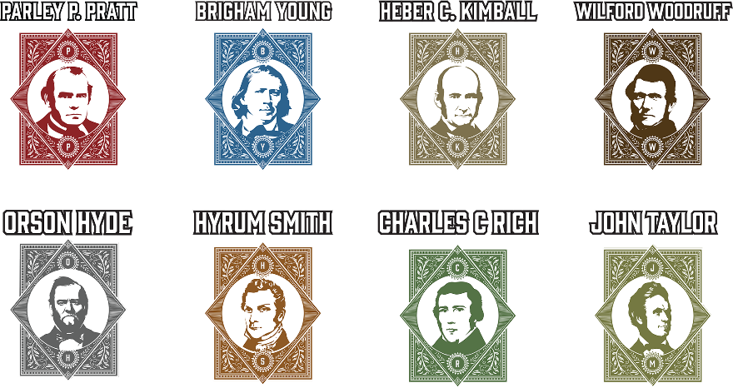

Schedule
Monday
Time | Action
3:30p – 5:00p | Drive to Ensign Ranch
5:00p – 6:00p | Arrival and registration
6:00p – 7:00p | Dinner at the Cookhouse
7:00p – 8:00p | Welcome and Sorting Ceremony @ Temple Lot: young men sorted into Companies
8:00p – 8:30p | Grab gear and unload at your Camp
8:30p – 9:30p | Read Zion’s Camp Disciple’s Guide
9:30p – 10:00p | Wind down @ your Camp
10:00p | Lights out / quiet time

Tuesday
Time | Action
7:30a – 8:00a | Wake up, get ready, and tidy camp
8:00a – 8:30a | Personal Study @ your camp
8:30a – 9:00a | Go to Cookhouse and pick up breakfast  (pick up ends at 8:45a)
9:00a – 9:30a | Company Study @ your camp  (led by Company Captains)
9:30a – 10:00a | Read Times & Seasons; travel to 1st Challenge
10:00a – 12:15p | Complete Challenges and Daily Diligences (Part I)
12:15p – 1:00p | Go to Cookhouse and pick up your lunch  (pick up ends at 12:30p)
1:00p – 4:45p | Complete Challenges and Daily Diligences (Part II)
4:45p – 6:00p | Free Time
6:00p – 7:00p | Gather for dinner @ Cookhouse
7:00p – 8:00p | Devotional @ Temple Lot
8:00p – 9:00p | Free Time
9:00p | Headcount @ your Camp  (done by Company Captains)
9:00p – 9:30p | Nightly Debrief @ your Camp  (lead by Adult Leaders)
9:30p – 10:00p | Personal Journaling @ your Camp  (Company Captains meet w/ Aaronic Priesthood Camp Leaders
10:00p | Lights out / quiet time

Wednesday
Time | Action
7:30a – 8:00a | Wake up, get ready, and tidy camp
8:00a – 8:30a | Personal Study @ your camp
8:30a – 9:00a | Go to Cookhouse and pick up breakfast  (pick up ends at 8:45a)
9:00a – 9:30a | Company Study @ your camp  (led by Company Captains)
9:30a – 10:00a | Read Times & Seasons; travel to 1st Challenge
10:00a – 11:30a | Complete Challenges (Part I)
11:30a – 12:15p | Complete Daily Diligences
12:15p – 1:00p | Go to Cookhouse and pick up your lunch  (pick up ends at 12:30p)
1:00p – 2:30p | Complete Challenges (Part II)
2:30p – 3:15p | Pack and prepare for March to Missouri
3:15p – 5:00p | March to Missouri
5:00p – 6:00p | Set up Camp
 | Eat dinner @ your Camp
7:00p – 8:00p | Gather for Devotional
8:00p – 9:00p | Free Time
9:00p | Headcount @ your Camp  (done by Company Captains)
9:00p – 9:30p | Nightly Debrief @ your Camp  (lead by Adult Leaders)
9:30p – 10:00p | Personal Journaling @ your Camp  (Company Captains meet w/ Aaronic Priesthood Camp Leaders
10:00p | Lights out / quiet time

Thursday
Time | Action
7:00a – 8:00a | March back to Kirtland
8:00a – 8:30a | Personal Study @ your camp
8:30a – 9:00a | Go to Cookhouse and pick up breakfast  (pick up ends at 8:45a)
9:00a – 9:30a | Company Study @ your camp  (led by Company Captains)
9:30a – 10:00a | Read Times & Seasons; travel to 1st Challenge
10:00a – 11:30a | Complete Challenges (Part I)
11:30a – 12:15p | Complete Daily Diligences
12:15p – 1:00p | Go to Cookhouse and pick up your lunch  (pick up ends at 12:30p)
1:00p – 4:00p | Complete Challenges (Part II)
4:00p – 6:00p | Free Time
6:00p – 7:00p | Gather for dinner @ Cookhouse
7:00p – 8:00p | Devotional @ Temple Lot
8:00p – 9:00p | Free Time
9:00p | Headcount @ your Camp  (done by Company Captains)
9:00p – 9:30p | Nightly Debrief @ your Camp  (lead by Adult Leaders)
9:30p – 10:00p | Personal Journaling @ your Camp  (Company Captains meet w/ Aaronic Priesthood Camp Leaders
10:00p | Lights out / quiet time

Friday
Time | Action
7:30a –8:00a | Wake up, get ready, and tidy camp
8:00a – 8:30a | Go to Cookhouse and pick up your breakfast - eat where you like  (pick up ends at 8:15a)
8:30a – 10:00a | Testimony Meeting at Temple Lot
10:00a – 11:00a | Pack up and check out
11:00a –12:30p | Return home

Your Backstory
In 1820, Joseph Smith experienced the First Vision, where he saw God the Father and Jesus Christ and a way was opened for the restoration of God’s true church on the earth.
On April 6, 1830, the Church was organized in Fayette, New York with Joseph called as its Prophet. Living there, you learn about this exciting new religion and are baptized.
As the Church grows, your neighbors feel uneasy about stories of angels and “Gold Bibles”. You and your fellow Saints are persecuted and treated unfairly.
Seeking a place to practice your faith freely, the Prophet receives revelations (D&C 37-38) directing Saints to gather in Kirtland, Ohio. It’s difficult, but you sell your farm and move to Ohio.
After a few years, you feel settled and start to build a temple, awaiting the spiritual blessings it will bring.
Other Saints settle in Jackson County, Missouri which you believe to be Zion, where Jesus Christ will come when he returns.
But trouble is brewing as Saints in Missouri face opposition and violence from local settlers who feel threatened by their presence.
You may be called upon to help…

Zion’s Camp Experience
Ensign Ranch represents the United States from this era of Church history with the Ayatma camp serving as Kirtland, Ohio.
Your Zion’s Camp experience is to immerse yourself in church history as you assemble a deck of cards by completing spiritual, intellectual, and physical challenges.
For each card, you earn Kirtland Safety Society Notes (KSSN) that can be used at the Newel K. Whitney Store to buy treats and cool stuff (see the Store section).
The more cards you collect the more rewards you earn!
Collect 36 Base cards valued at 6 KSSN each:
Card Type | # of Cards | How to Earn
Daily Devotions* | 3 | Perform the devotions
Daily Diligences | 3 | Carry out the diligences
Historical Figures | 8 | Perform service for others
Artifacts | 8 | Find the hidden artifact
Challenges** | 14 | Complete the challenge
*Instead of KSSN, you earn Mana that can be redeemed at Store for sustenance.
**Varies by achievement: Star = 6 KSSN, Moon = 8 KSSN, and Sun = 12 KSSN.
Collect 7 Bonus cards valued at 30 KSSN each.
Card Type | # of Cards | How to Earn
Daily Devotions* | 1 | Do all Daily Devotions
Daily Diligences | 1 | Do all Daily Diligences
Historical Figures | 1 | Earn all Historical Figures
Artifacts | 1 | Find all the Artifacts
Challenges | 3 | Complete all Challenges
*Instead of KSSN, you earn Mana that can be redeemed at Store for sustenance.
Collect 4 Mystery cards valued at 30 KSSN each.
Card Type | # of Cards | How to Earn
Mystery | 4 | ??

Daily Devotions
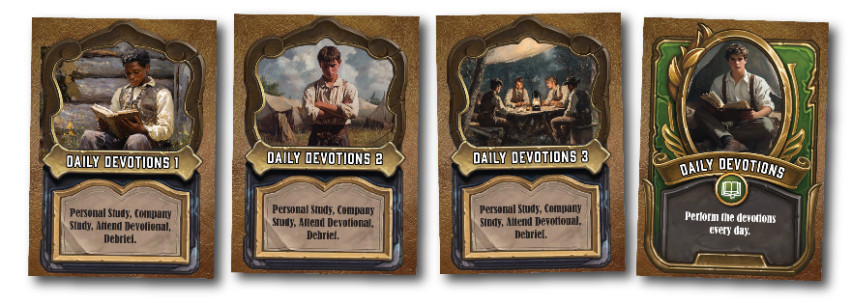
One card can be earned per day by doing the following:
- Do Personal Study and Journaling*
- Participate in Company Study
- Attend Devotional each evening
- Participate in Nightly Debrief
*Suggested daily reading can be found in the Personal Study section
After Company Study is completed, Adult Leaders provide a Mana token to be redeemed at the Newel K. Whitney Store for sustenance to fuel your journey that day.

Earn all 3 cards to unlock Bonus card and special Mana reward.

Daily Diligences
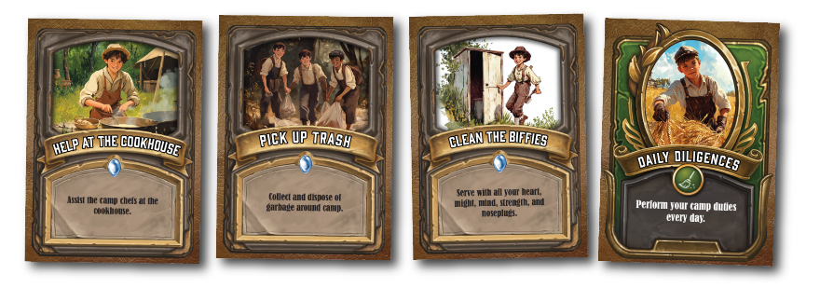
One Daily Diligence card can be earned per day by doing the following per below schedule:
- Clean Biffies (porta-potties, 4 of them) and the flush toilets
- Help in the Cookhouse (as cooks how you can help)
- Pick 5 pieces of trash per Company member
Camp Duty | Tuesday | Wednesday | Thursday
Clean Biffies | Pratt,  Young,  Kimball | Woodruff,  Hyde,  Smith | Rich,  Taylor
Help in Cookhouse | Rich,  Taylor | Pratt,  Young,  Kimball | Woodruff,  Hyde,  Smith
Pick up Trash | Woodruff,  Hyde,  Smith | Rich,  Taylor | Pratt,  Young,  Kimball

After Daily Diligences are completed, Adult Leaders provide the card and 6 KSSN reward.
Earn all 3 cards to unlock the Bonus card and 30 KSSN reward.

Historical Figures
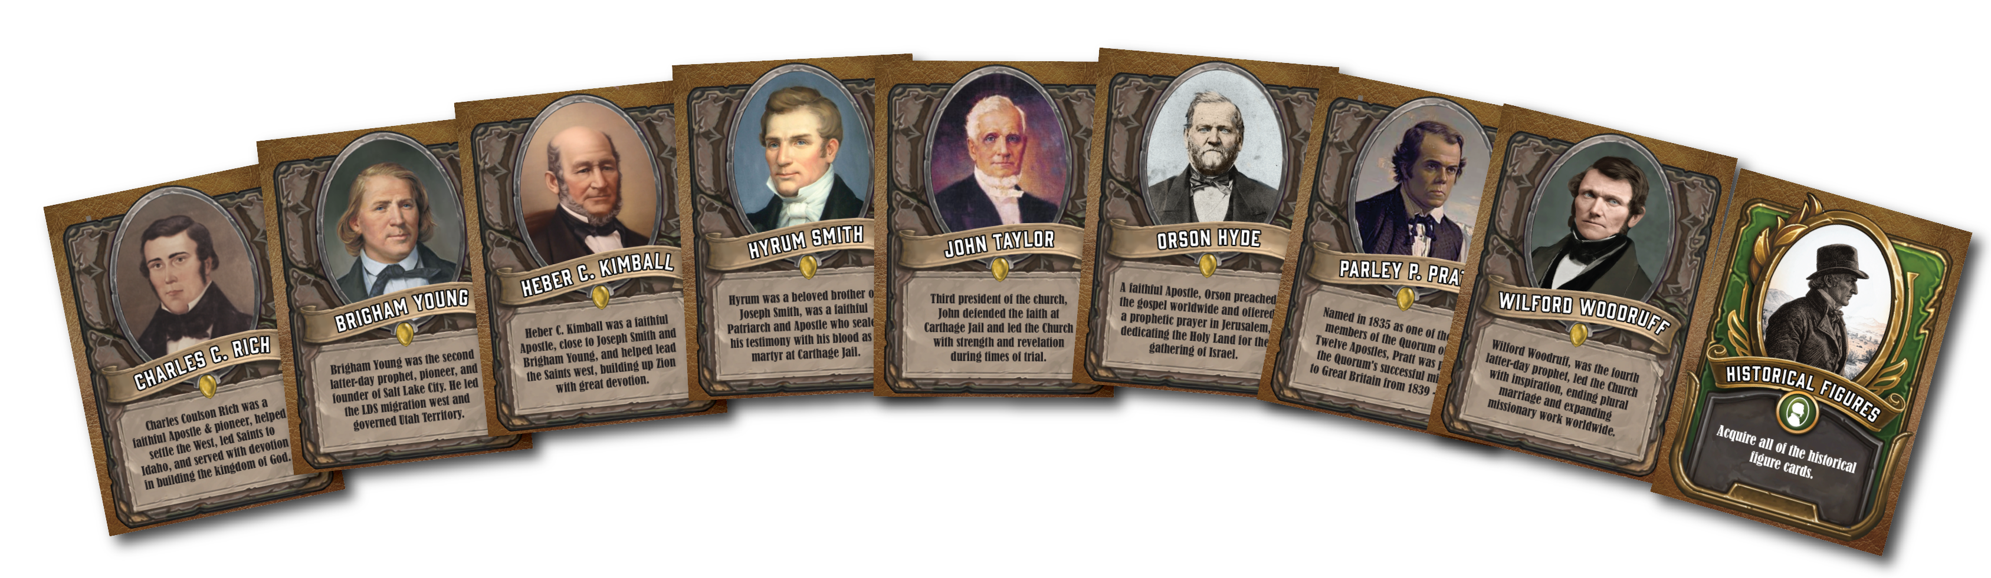
There are 8 Historical Figure cards.
- Be default, you receive the Historical Figure card for the Company that you are a part of.

- You earn the remaining 7 cards by performing service for the Companies representing the Historical Figure.

- Service should be meaningful and take at least 15 min.
After each service is completed, Adult Leaders provide the card and 6 KSSN reward.
Earn all 8 cards to unlock the Bonus card and 30 KSSN reward.

Artifacts

Earn 8 cards by finding Artifacts hidden around Ensign Ranch. Look for these when you have free time.
Artifact | Fun Fact
Porter Rockwell’s Pistol | Porter Rockwell was known as the “Destroying Angel” and was a bodyguard to Joseph Smith.
John Taylor’s Pocket Watch | Believed to have stopped at bullet when he was shot in Carthage Jail.
Temple Cornerstone | The Kirtland Temple was the first built by the church in this dispensation.
Odometer Cog | Part of the “roadometer”, built to track mileage on the journey west.
Egyptian Papyrus | Purchased from a traveling Egyptian exhibition that came to Kirtland; some were translated into the Book of Abraham in the Pearl of Great Price.
Spittoon | Church leaders used to chew and smoke tobacco while being instructed by the Prophet until the Word of Wisdom was received in 1833.
Kikthawenund’s Book of Mormon | A Native American chief visited by Oliver Cowdery and other missionaries who left him with a copy.
Temple Key | Symbolic of the keys that were restored to Joseph Smith in the Kirtland temple in 1836 by Moses, Elias, and Elijah.

When you find an Artifact, an Adult Leaders will validate the find and reward you with the card and 6 KSSN reward.
Earn all 8 cards to unlock the Bonus card and 30 KSSN reward.
NOTE
You do not need to bring the Artifact back to camp but should leave it there for other Companies to find.
Your Company must stay together when searching for Artifacts; breaking into smaller groups is not permitted.
When looking, if you see a pink ribbon , you are within 30 feet of the Artifact.
Artifacts will change locations during the week and can only be found once by each Company.
Revealing the location of an Artifact to other Companies will result in your Company losing all KSSN for finding Artifacts.
Don’t spoil the fun.

Challenges
Earn 14 Challenge cards by completing a series of tasks each day.
Theme | Day | Challenges
Book of Commandments  Retrieve the scattered sections of scripture | Tuesday | 7 cards + Bonus card  - Sections 1-9  - Sections 10-18  - Sections 19-27  - Sections 28-36  - Sections 37-45  - Sections 46-54  - Sections 55-65
Redeem Zion  Prepare for and take your journey to Missouri | Wednesday | 4 cards + Bonus card  - Build Rifle  - Target Shoot  - Catch a Fish  - March to Missouri
House of the Lord  Help build the Kirtland Temple | Thursday | 3 cards + Bonus card  - Find Caroline  - Spin Wool  - Perform Service

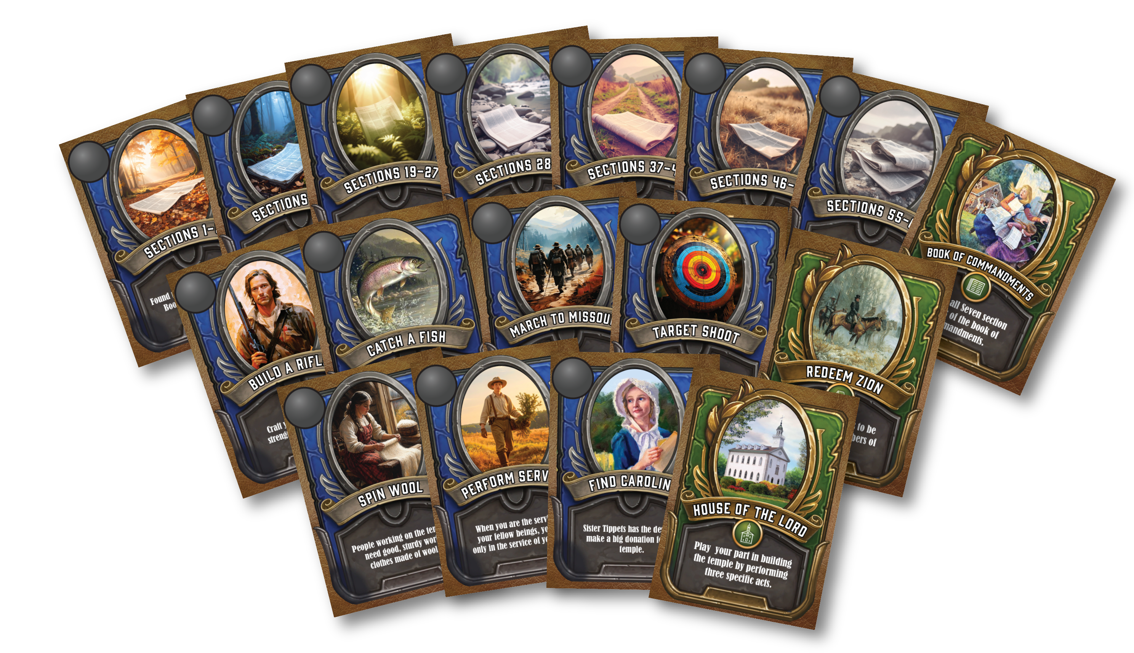
Depending on how you perform, each Challenge offers a different KSSN reward:
- Star = 6 KSSN
- Moon = 8 KSSN
- Sun = 12 KSSN
After each Challenge is completed, Adult Leaders provide the card. Rewards will be announced prior to the Devotional.
Companies will be rewarded for performance as follows:
- The top company receives Sun rating and 12 KSSN
- The next five receive Moon rating and 8 KSSN
- The last two three receive Star rating and 6 KSSN
Adult Leaders will provide a Sun, Moon, or Star sticker to place on the card in addition to the corresponding 6 KSSN, 8 KSSN, or 12 KSSN reward.

Earn all Challenge cards for that day to unlock the Bonus card and 30 KSSN reward.


Mysteries
The Kingdom of God is full of mysteries and Zion’s Camp is no different.


There are 4 Mystery cards you can earn. Opportunities will present themselves during your camp experience.
After each Mystery is discovered and completed, Adult Leaders provide the card and a 12 KSSN reward.

Card Canvas
Before gathering for the Devotional each evening, you should arrange earned cards on the Card Canvas as shown.
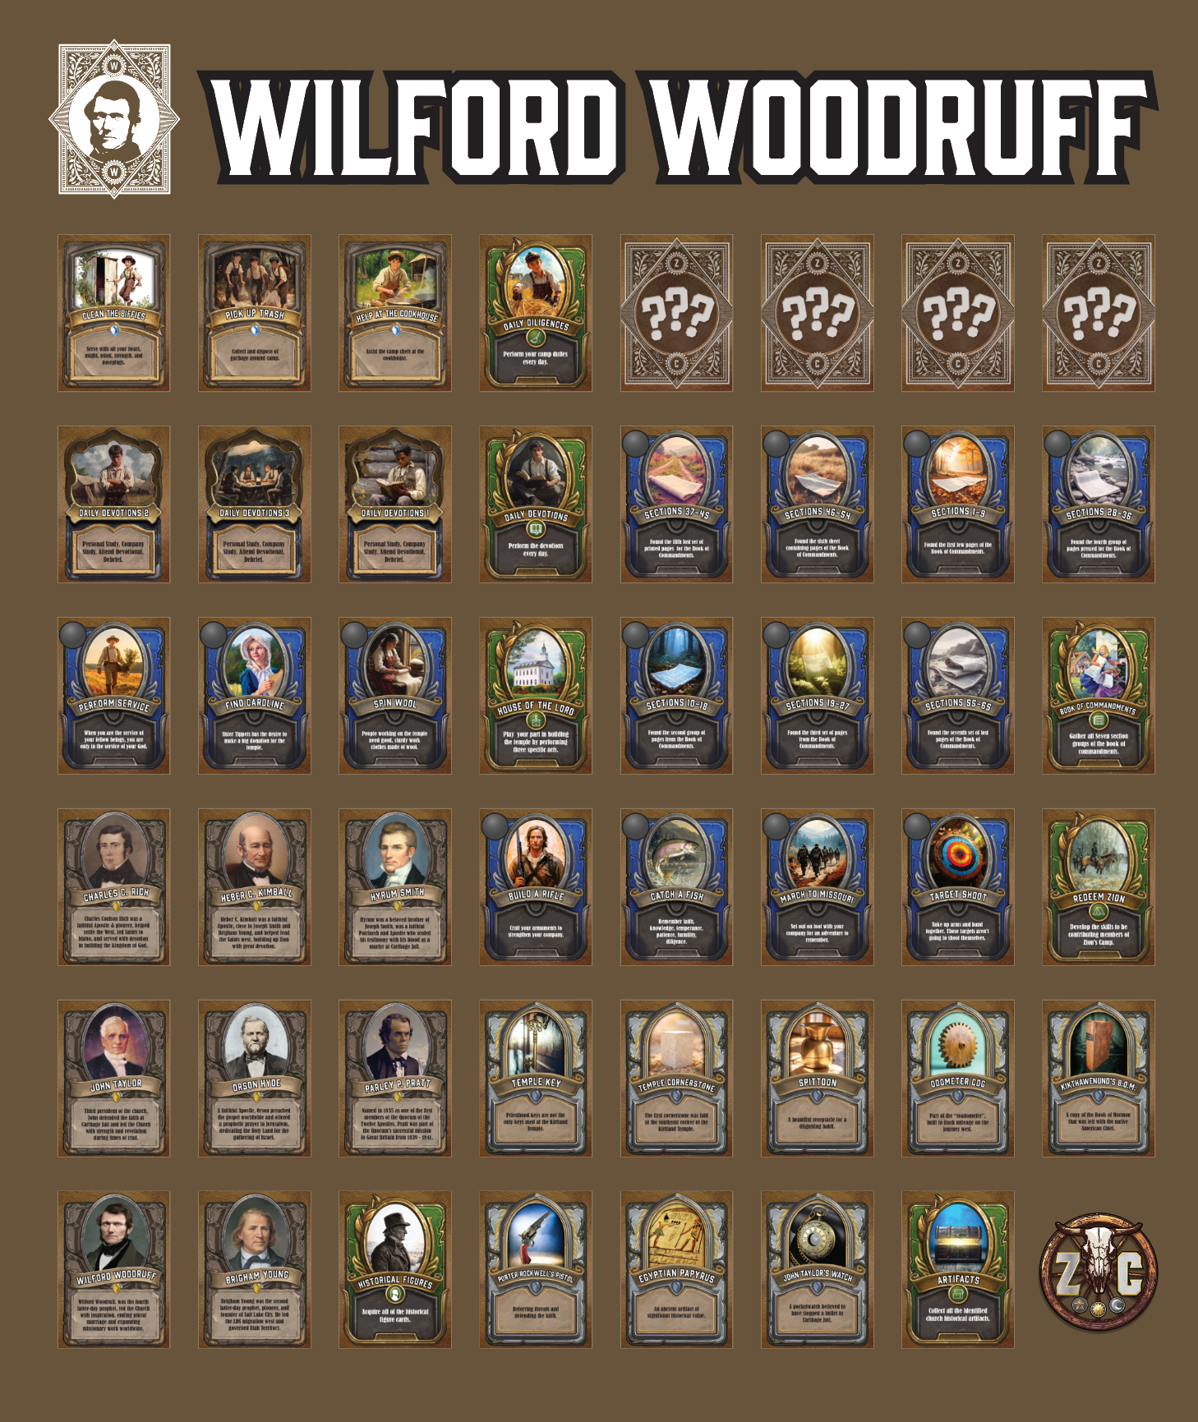
Card Canvas’s are found at the Temple Lot near the Mega Map.
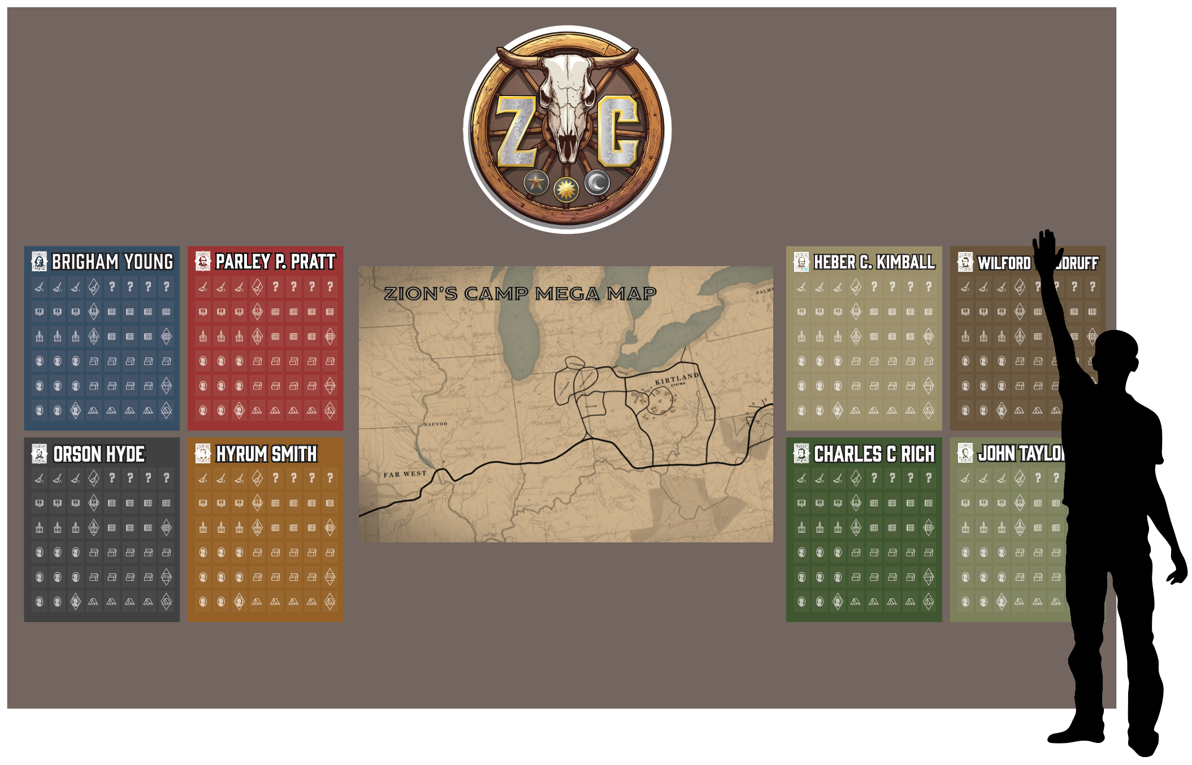
The Mob
Watch out for the Mob, there are a few on the loose around camp!
If you hear “HEY MORMONS!” this means you’ve been spotted by the Mob and must face a challenge.
Lose the challenge, and the Mob will take 12 KSSN and give you a Tarred & Feathered card to place on your Card Canvas. While on your canvas this card prevents you from earning Bonus cards.
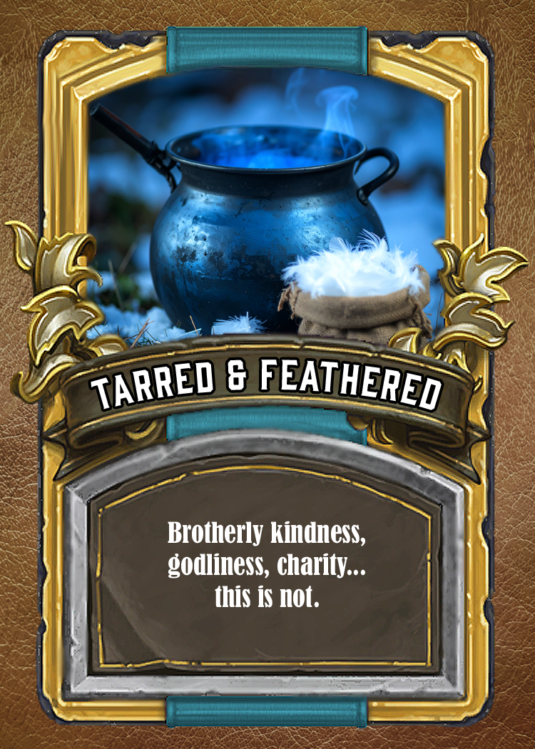
The Tarred & Feathered card is removed from your Card Canvas after members of your Company recite D&C 4 from memory to your Adult Leaders. You may divide up the verses by having different members memorize each one.
You can only face the Mob once.
NOTE
If you run from or harass the Mob in any way, you will face a 12 KSSN penalty. Don’t mess with the Mob, they mean business.
While we’ve made the Mob harmless as part of Zion’s Camp, many early Saints faced persecution and physical harm for their beliefs. It’s important to remember their sacrifices in building up Zion 
Times & Seasons
Each morning, you will receive the Times & Seasons newspaper that will reveal Challenges you will tackle for the day and provide other news of interest. Read it cover to cover.
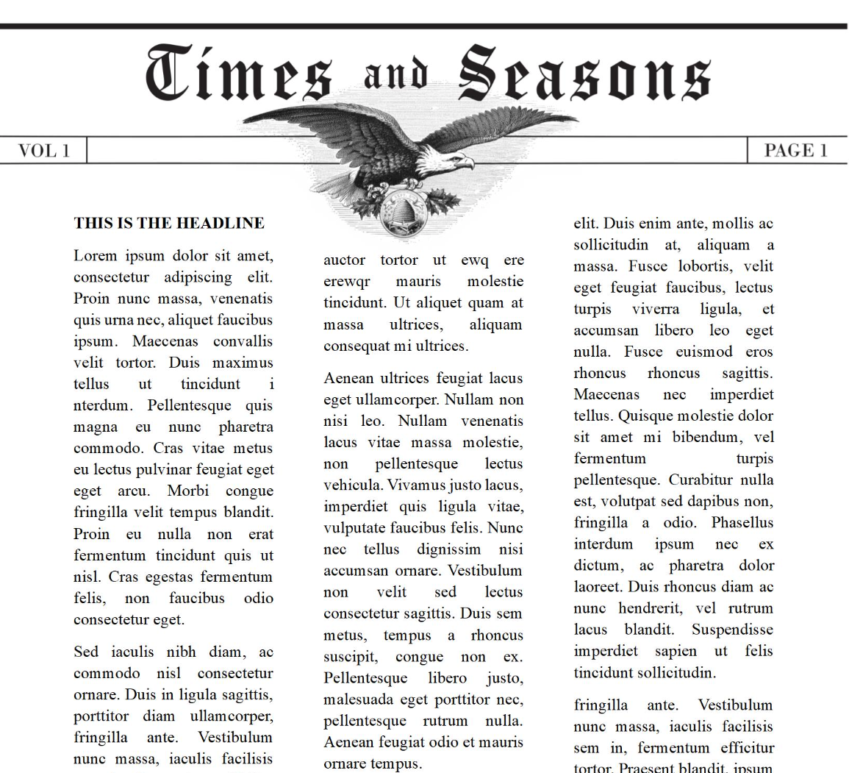
Throughout the day you may also receive “missives” or letters from your Adult Leaders at specific times, letting you know of news or giving you special instructions.


Company Captains
Each Company has two Company Captains who are distinguished by band of Company colors tied around their arm.
Their responsibilities include…
- Lead by example and love as the Savior would
- Lead morning Company Study
- Keep schedule and be on time to all events
- Lead company in completing Camp Diligences
- Carry KSSN and cards in Messenger Bag
- Keep Company together when adventuring
- Do nightly headcount before bedtime
- Ensure Company is in bed and quiet by 10:00pm
- Encourage, love, and support one another
If Companies are stuck in Zion’s Camp, they may purchase hints from Adult Leaders (see Adult Leader section).
When it’s hard to make decisions, Company Captains should convene a Company Council and decide on the best path.
In a Company Council…
- You start with a prayer and invite the Spirit
- Everyone is encouraged to speak freely and share
- When there is unity and peace about the decision, you conclude the council
Company Captains make extra effort to make sure everyone feels included and heard even if they don’t agree with the final decision of the council.

Messenger Bag
This sweet bag is to be always carried by Company Captains while adventuring and is used to store KSSN and cards until they are placed on the Card Canvas.
NOTE
Any Company found adventuring without their Messenger Bag will be fined 6 KSSN.
It contains 8 KSSN to start your adventures.
When the Company returns to camp, KSSN can be divided among Company members (if you choose) and cards are placed on the Card Canvas.



Adult Leaders
Each Company has two appointed Adult Leaders
These leaders…
- Dispense cards and rewards for completed activities
- Conduct the Nightly Debrief
- Can give hints (for a price) when Companies are stuck
- Ensure no Company Member is in physical or emotional danger at any time
NOTE
Aside from Nightly Debriefs, Adult Leaders are observers only during Zion’s Camp, intervening only to prevent injury or provide hints when they are purchased.
Three hints per day are allowed.
Hint | Cost
1st hint | 5 KSSN
2nd hint | 6 KSSN
3rd hint | 12 KSSN

Newel K. Whitney’s Store
The Store is open during free time and mealtimes and has treats and cool stuff you can buy with your hard-earned Kirtland Safety Society Notes (KSSN).
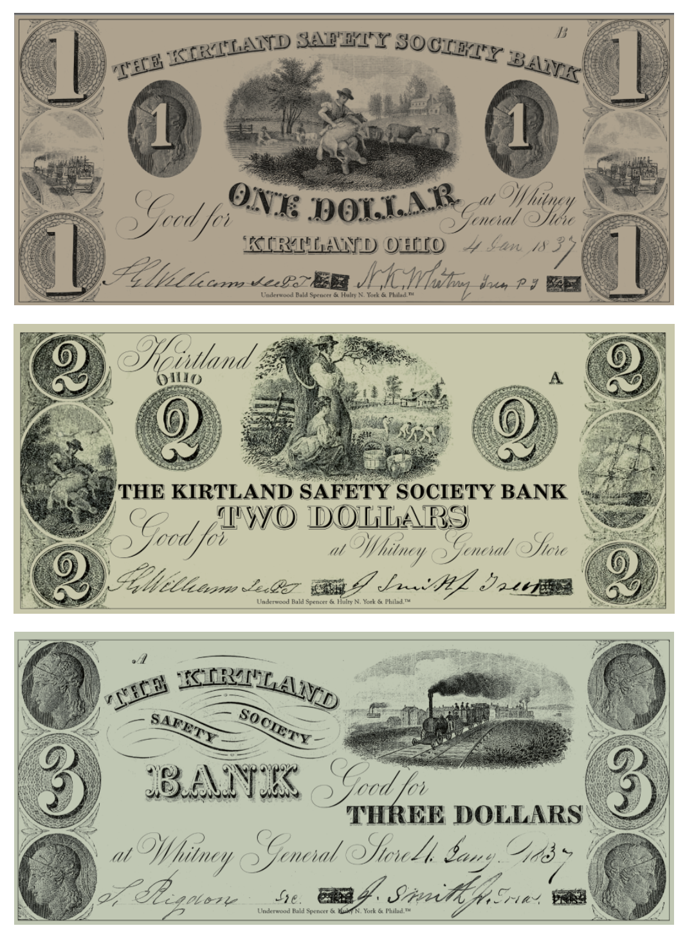
Fun Fact: at one time the Church created a bank called the Kirtland Safety Society that printed money that KSSN are based on.
After completing Company Study each morning, Companies can redeem Mana tokens for sustenance to eat during the day.

Sustenance (that means food!)
Staying fueled is key to completing Zion’s Camp!
Here’s how meals work:
Meal | How it works | Location | Time
Breakfast | Pick it up and eat where you like | Cookhouse | 8:30a – 9:00a
Lunch |  |  | 12:15p – 1:00p
Dinner | Companies eat together |  | 6:00p – 7:00p

NOTE: if you miss the window to pick up your breakfast or lunch you will go hungry. So don’t miss it !
Be on time for dinner at 6:00p and earn 6 KSSN!

You can also get food from Newel K. Whitney’s:
Opportunity | How it works | When Store is open
Redeem Mana for snacks | Do morning Company Study | Free Time and Mealtime
Purchase treats with KSSN | Earn  Cards

Reward Table Summary
KSSN are earned for more than collecting cards. Here is a complete summary of reward opportunities.
Item | Reward
Wake up, get ready and tidy camp | 6 KSSN
Complete Company Study as part of collecting Daily Devotions card | 1 Mana token
Collect cards for…  - Daily Diligences  - Historical Figures  - Artifacts | 6 KSSN each
Collect Challenge cards | Star = 6 KSSN  Moon = 8 KSSN  Sun = 12 KSSN
Collect Bonus cards for…  - Daily Diligences  - Historical Figures  - Challenges  - Artifacts | 30 KSSN
On time for dinner | 6 KSSN
On time and reverent for Devotional | 6 KSSN
Headcount completion  (conducted by Company Captains) | 6 KSSN
Participate in Nightly Debrief
(conducted by Adult Leaders)
In bed, lights out by 10:00p
(conducted by Company Captains)

Personal Study
Each morning you have time for Personal Study followed by Company Study. You’ll learn of challenges the Saints faced and how they overcame them. Think about how this can apply to you.

Tuesday’s Study
While the early church was established in New York, it began to grow and the Lord asked members to gather in Kirtland, Ohio.
Read D&C 37: 1-4
The call to move to Ohio felt like fulfilling ancient prophecy in the Bible and Book of Mormon to gather God’s people in the last days to protect them from harm.
The idea of moving to Ohio was a big surprise and many members were worried. It was far away, not many people lived there, and most Saints knew nothing of the area. They would lose money selling their farms and homes.
To help them feel better, Joseph asked the Lord for help and the Lord gave this revelation:
Read D&C 38:18-22, 32-33
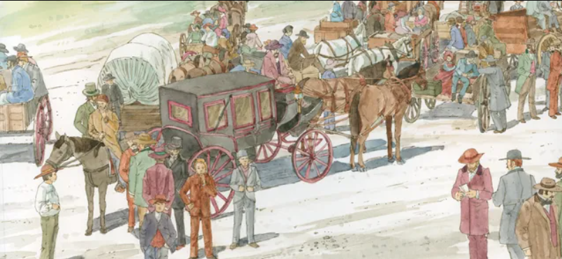
Like the Saints, what’s something you may give up because of your faith or beliefs? How does it feel to make that sacrifice?
The Saints were promised blessings for moving to Ohio. What blessings do you see when you choose to follow God even when it can be hard?

Wednesday’s Study
The Lord declares that Missouri is Zion, the land of promise and instructs some of your fellow Saints to purchase lands and begin settling there.
Read D&C 57: 1-4
The Saints that settle in Missouri struggle to keep the commandments and are prideful and selfish. As a result, they may lose Zion and its’ promises of spiritual blessings.
Read D&C 101:1-8
But God promises he will not forget them even when they aren’t perfect; he promises that Zion will be redeemed.
Read D&C 101:9,13-17
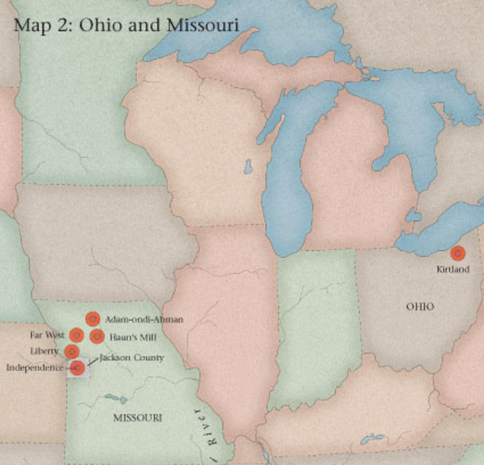

The Saints in Missouri struggled with contention and selfishness. How can these things hurt our relationships with others?
Even though the Saints struggled, God promised he wouldn’t forget them. How does it make you feel to know God won’t forget you when you make mistakes?
Thursday’s Study
After Zion’s Camp, the Lord commands the Saints to continue work on the temple in Kirtland, Ohio. Though they are poor and few, they obey.
Read D&C 88: 119, 95:8,11-13
The Kirtland Temple becomes a place of great spiritual power and learning. Sacred ordinances are performed there, Jesus Christ visits, and heavenly beings such as Moses, Elijah, and Elias appear.
Read D&C 110:1-16
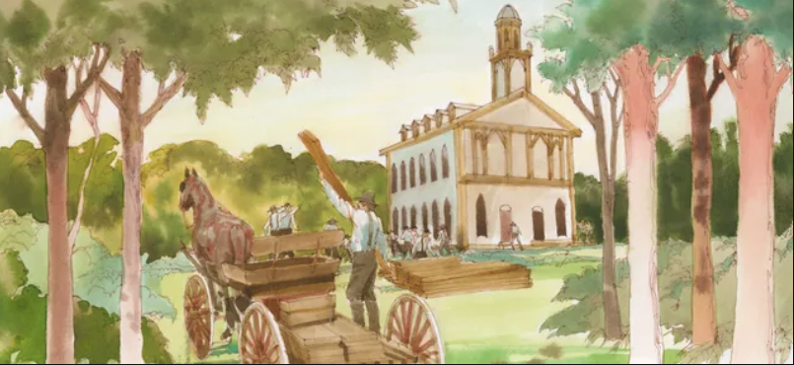

Why do you think the Lord wanted the Saints to build a temple in Kirtland even though they had very little? Why was it so important for the early church?
What blessings have you seen in your life as a result of the temple? What does it mean to be “endowed with power”?

Kirtland (Ayatma) Map
